Chapter 1
- Introduction
Light Fidelity (Li-Fi) is a technology based on Visual Light Communication (VLC) that uses light emitting diodes (LEDs) to a wireless system completely connected to the network. Allows the electronic device to connect to the Internet without using a cable. To establish a communication line between the node, the Li-Fi device needs a transceiver to transmit and receive data. Li-Fi can be used for various applications, this document focuses on in-depth studies of Li-Fi applications and on their comparison. Different applications that require a Li-Fi communication system are used in hospitals to monitor children, vehicle-vehicle communications, aircraft to provide high-speed Internet, underwater, where radio frequencies (RF) are hard to reach, load balancing and sensitivity areas, in which the radio frequency can be easily disturbed. This document also focuses on how these applications work and how Li-Fi makes a difference when they are not in the picture. Li-Fi is a good replacement for Wi-Fi as technology evolves, technology-related applications are moving forward. Because all technologies have advantages, there are also some disadvantages. This document will discuss the advantages and disadvantages of Li-Fi and where exactly this technology is used in real-time applications and how it helps us improve our lives. Images are shown below because Li-Fi is used in real-world applications.
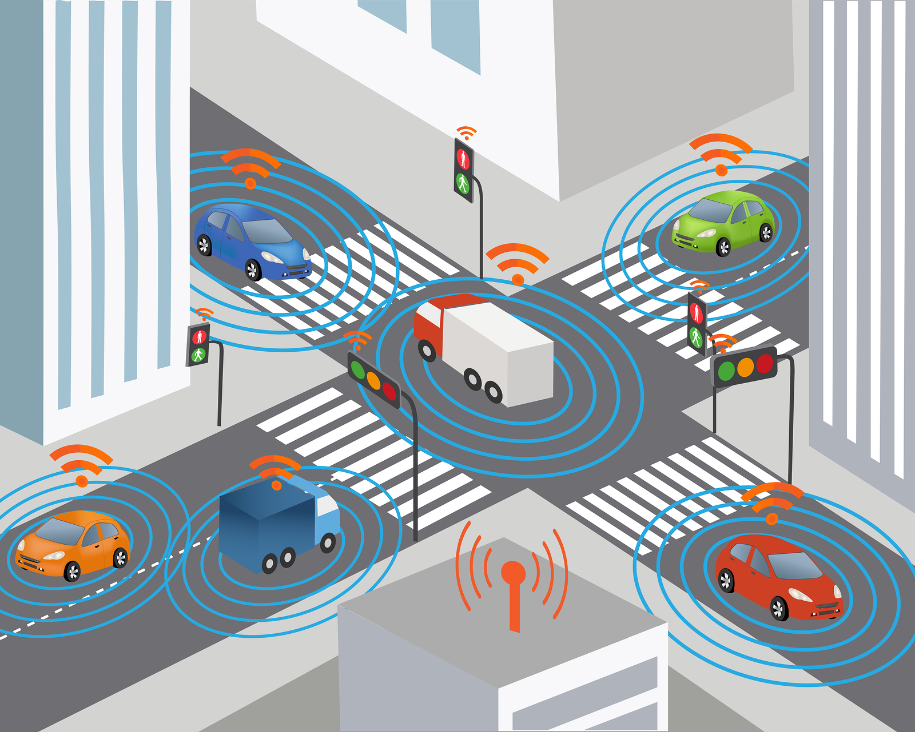
Fig 1.1: Vehicle to Vehicle Communication using Li-Fi
Reference from einfochips.com
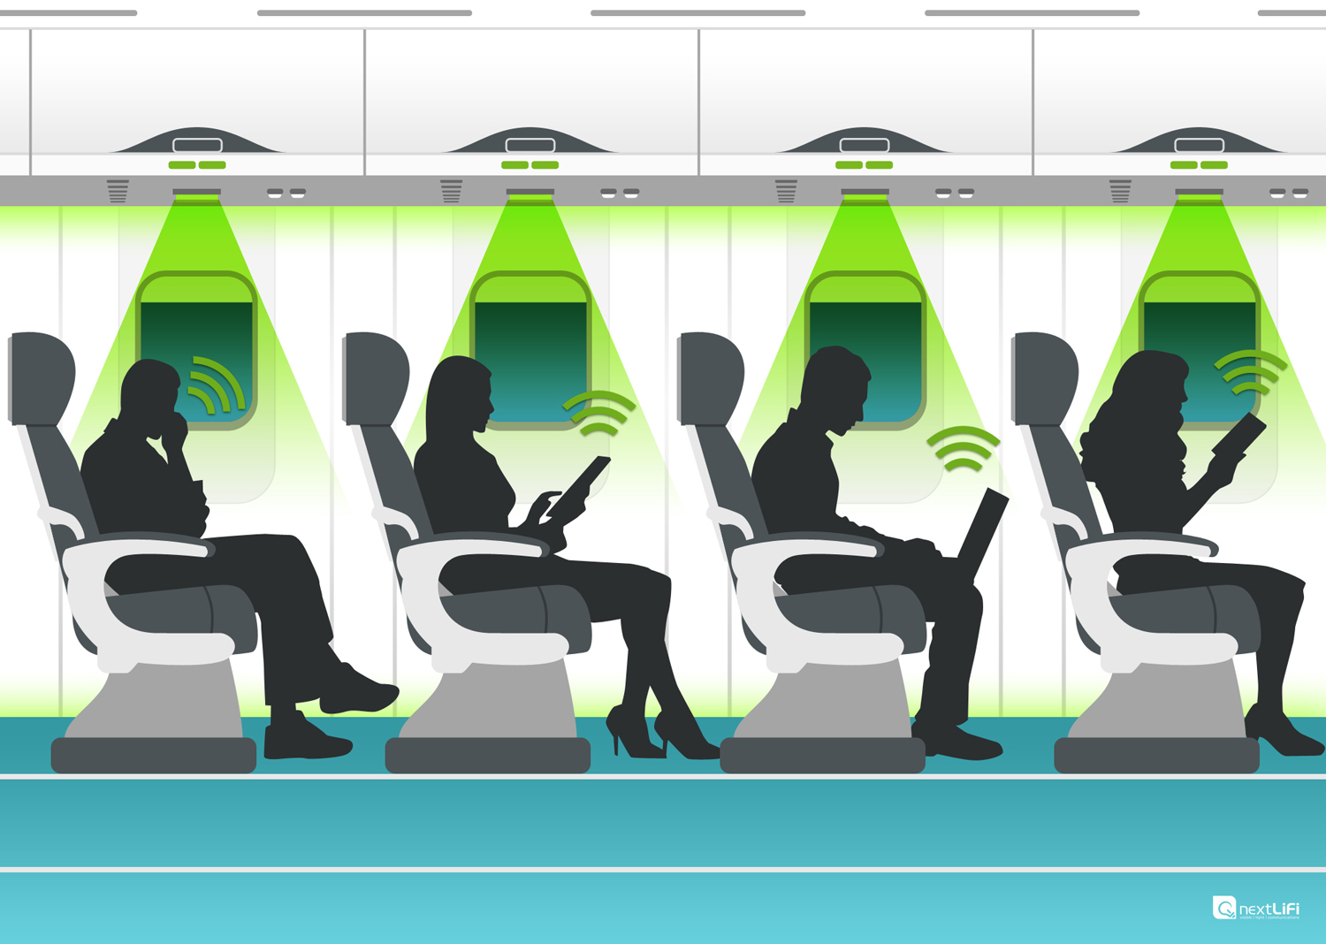
Fig 1.2: Li-Fi in airplanes
Reference from nextlifi.com
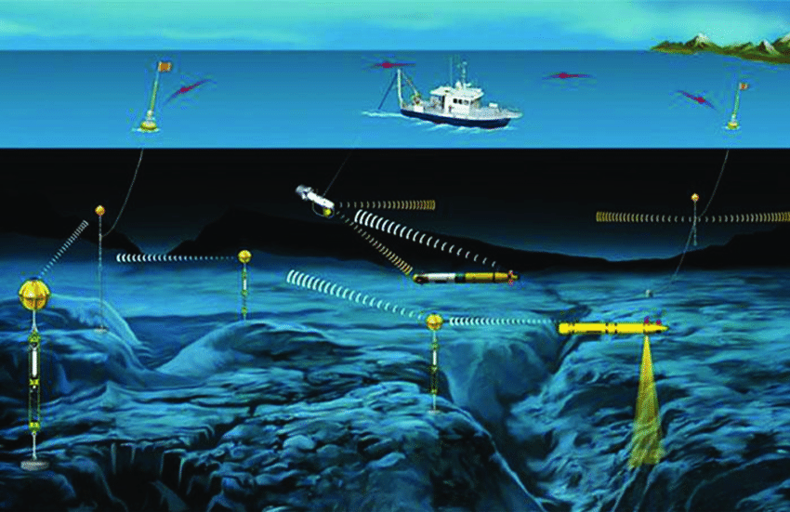
Fig 1.3: Use of Li-Fi underwater
Reference from tmu.ac.in
  - What is Li-Fi
According to figure 1, Li-Fi technology consist of LED Lamp as the media transmission and photo detector as a receiver of transmitted data. Lamp driver is needed to make LED working properly. While amplification and processing are responsible to manage the signal that comes from the photodetector.
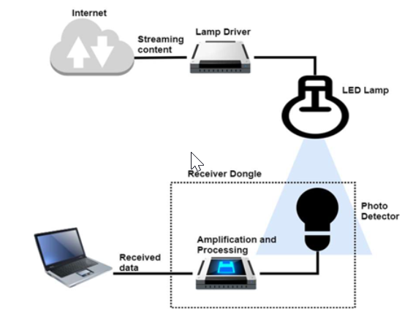
Fig 1.1.1: Basic Concept Diagram of Li-Fi
Reference from researchgate.net
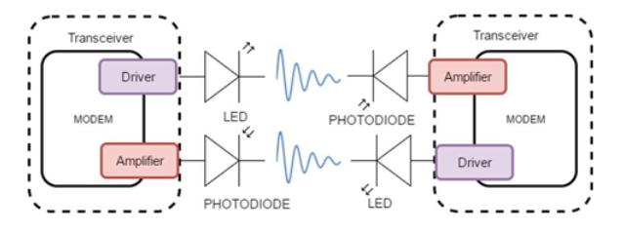
Fig 1.1.2: Transceiver Li-Fi based on Visible Light Communication
Reference from researchgate.net
The basic concept for working principle in Li-Fi Technology is pointing into Transceiver and Light as a media transmission. Figure 2 is a basic concept block diagram for Li-Fi. This basic concept indicates a duplex communication. The rates of Li-Fi is 14Gbps using three off- the- shelf laser diodes (red, green, and blue) and predict the rate until 100Gbps when the whole visible spectrum is used. According to Li-Fi and VLC used a similar medium as a data communication that is light. The difference between Li-Fi and VLC is VLC has a unidirectional, point-to-point light communication at low data rates. While Li-Fi technology is fully networked, bidirectional, and high-speed wireless communication. Others said Li-Fi is the incorporation of Wi-Fi and VLC.
  - Working of Li-Fi
Li-Fi is a two-way high-speed, mobile data communication network through light. Li-Fi consists of multiple bulbs that form a wireless network.
When an electric current is applied to an LED bulb, a current of light (photons) is emitted from the bulb. LED bulbs are semiconductor devices, which means that the brightness of the light flowing through them can be changed at extremely high speeds. This allows us to send a signal that modulates light at different speeds. The signal can be received by a detector that interprets changes in light intensity (the signal) as data.
The human eye cannot see the modulation of intensity, so communication is as perfect as that of other radio systems, which allows users to connect where there is light enabled for Li-Fi. Using this technique, data can be transmitted from a high-speed LED bulb.
  - Problem Statement
The major challenge with existing technologies is its low data, transmission speed, high power consumption, and limited bandwidth. Despite continuous improvements in wireless communication systems, e.g. 2G, 3G, 4G, etc.., a coming crisis is expected due to the lack of enough Radio Frequency (RF) resources, this limitation in bandwidth can’t support the growth in demand for high data rates and the large numbers of communication systems, within the bandwidths between 300 kHz and 4 GHz. That’s known as “Spectrum Crunch”. Although, spectrum congestion decreases when higher frequencies are used to transfer the data, this not a practice solution, because this part of the spectrum requires complex equipment and causes high-cost systems.
  - Limitations of the Current Work
Every technology has negative and positive aspects that are highly important to discuss before implementation. The Li-Fi system will be able to properly function when there is no light. During the day intense sunlight may interfere in the communication which can lead to the generation of error messages. Also, other light sources, such as normal light bulbs, may also interrupt the communication.

  - Objectives
- To study that Li-Fi technology is better in the vehicle to vehicle communication than other existing technologies.
- To explain how exactly the communication between the vehicles happens using Li-Fi technology.
- To study the existing systems and compare with the Li-Fi technology.

Chapter 2
- LITERATURE SURVEY
- R. Shanmughasundaram, S. Prasanna Vadanan, and V. Dharmarajan, "Li-Fi Based Automatic Traffic Signal Control for Emergency Vehicles," 2018 Second International Conference on Advances in Electronics, Computers, and Communications (ICAECC), Bangalore, 2018, pp. 1-5.
doi: 10.1109/ICAECC.2018.8479427
Implementation
An emergency vehicle consists of a Li-Fi transmitter which is implemented using its headlight. When it enters a traffic congested lane, it broadcasts an alert message like “EMERGENCY VEHICLE”. If there is a non-emergency vehicle in front of it, the alert message will be received by the transceiver of the non-emergency vehicle. When the non-emergency vehicle receives the alert message, the driver of the vehicle will be informed using the vehicle infotainment system. At the same time, it will transmit the alert message either to a vehicle, if present in front or to the traffic signal control. The signal control, on receiving the alert message, will turn green. The alert message can be hopped across any number of vehicles until it reaches the traffic signal control. Therefore, however long the traffic jam is, the alert message will reach the traffic signal control in a short span of time.
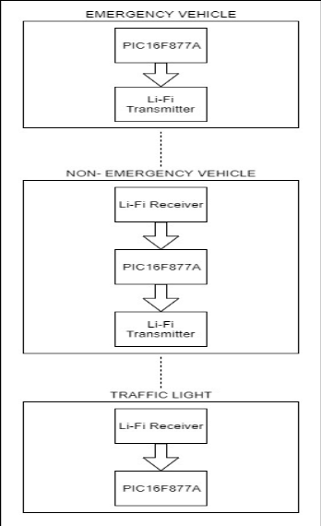
Fig 2.1: Block Diagram of Li-Fi based Traffic Control System
Reference from semanticscholar.org

Limitations
- The vehicle head and tail lights need to be kept ON even during the day for Li-Fi to work but the intensity can be maintained at a minimum level.
- Li-Fi works efficiently when the transmitter and receiver are placed in Line of Sight. Any deviation from this position can lead to miscommunication.
- During the day, intense sunlight may interfere in Li-Fi communication. Also, other light sources, such as normal light bulbs, may also interrupt the communication.

- Abdul Aleem Jamali, Mahesh Kumar Rathi, Abdul Hakeem Memon, Bhagwan Das, Ghanshamdas and Shabeena, "Collision Avoidance between Vehicles through Li-Fi based Communication System," IJCSNS International Journal of Computer Science and Network Security, VOL.18 No.12, December 2018
Implementation
The proposed system comprises a transmitter and a receiver section. The backlights of vehicle A are acting as a transmitter and are sending the pulses of 0s and 1s. The flickering of LEDs should be done very fast so that it cannot be visualized by the human eye. A photodiode which is placed in front of vehicle B is receiving the transmitted data in the form of current. The system is applicable to the scenario when vehicle A is braking, rear lights transmit the alert of brake to vehicle B so that collision can be avoided. Block diagram of transmitter and receiver respectively.
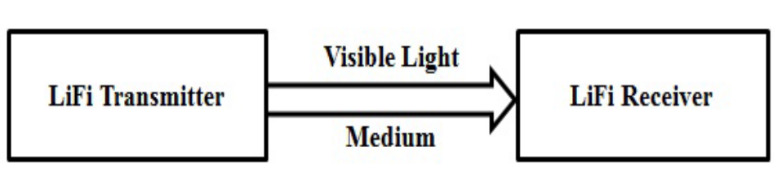
Fig 2.2: Block diagram of Li-Fi communication system
Reference Collision Avoidance between Vehicles through Li-Fi based Communication System
Limitations
Reliable property and network coverage are serious problems to be considered because of the interference from external light sources like sun bulbs, light and opaque materials in the path of transmission results in a disturbance in the communication.

- H. K. Yu and J. G. Kim, "Smart navigation with AI Engine for Li-Fi based Medical Indoor Environment," 2019 International Conference on Artificial Intelligence in Information and Communication (ICAIIC), Okinawa, Japan, 2019, pp. 195-199.
doi: 10.1109/ICAIIC.2019.8669041
Proposed System for Smart Navigation
To implement the system proposed in this paper, firstly, the location information of the user is collected. The user's LC device sends the beacon signal to the LED (AP) and transmits the current position of the patient. AP transmits location information of users to the Central Server. Central Server uses patient location information to create patient location information map. In the patient location information map, the user is divided into Using Patient, Waiting Patient, and Visitor. Patients who entered the patient's symptom using the LC Device are classified as using Patient and Waiting Patient, and others are classified as Visitor. Using Patient is a patient who is currently using a clinic. Waiting Patient is a patient waiting to use Clinic. The visitor is a patient who has not yet received it or a visitor who has visited the hospital.
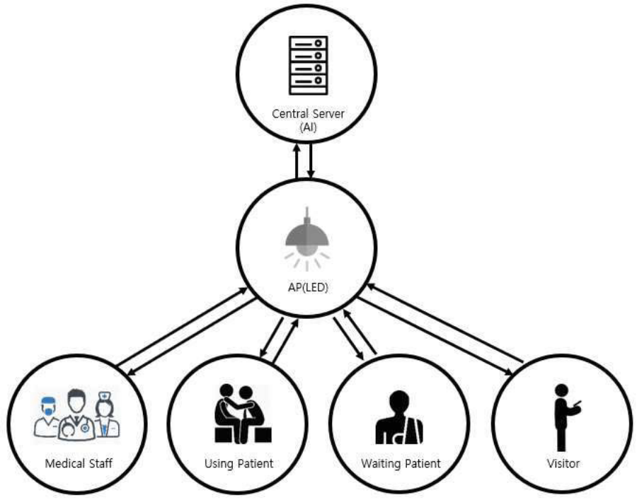
Fig 2.3: Conceptual diagram of transmitting and receiving local information
Reference from semanticscholar.org

- H. Ali, M. I. Ahmad, and A. Malik, "Li-Fi Based Health Monitoring System for Infants," 2019 2nd International Conference on Communication, Computing and Digital systems (C-CODE), Islamabad, Pakistan, 2019, pp. 69-72.
doi: 10.1109/C-CODE.2019.8681012
This system is proposed for the infants to monitor health parameters like Heartbeat and Oxygen Level. MAX30100 used for the monitoring of Heartbeat and Oxygen Level of the infant. Here they propose a compact system that can be installed in the infant’s bag. This system comprises of wearable sensors and wearable microcontrollers for physical flexibility of the infants.
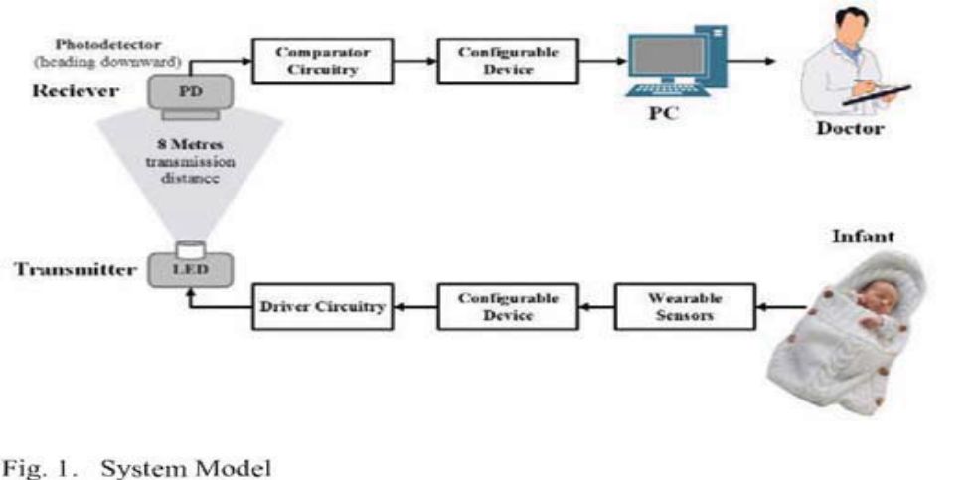
Fig 2.4: Architecture of Health Monitoring System
Reference from ieeexplore.ieee.org
- N. A. Abdulsalam, R. A. Hajri, Z. A. Abri, Z. A. Lawati and M. M. Bait-Suwailam, "Design and implementation of a vehicle to a vehicle communication system using Li-Fi technology," 2015 International Conference on Information and Communication Technology Research (ICTRC), Abu Dhabi, 2015, pp. 136-139.
doi: 10.1109/ICTRC.2015.7156440
Working Principle
This proposed system has two scenarios. The first scenario- when vehicle 1 is braking, the speed meter in the vehicle will be sensing that the current speed is lower than the previous speed. Thus, the information will be sent through the transmitter which is placed in the rear lights to the vehicle 2nd. The information will be received by the vehicle two using the photodiode which is placed at the front of vehicle one. A notice of (Slow DOWN) will be displayed in vehicle 2nd using an LCD. The second scenario- when vehicle 1st vehicle is in T- junction, it will keep sending its speed-information to vehicle 2nd using the LED at the headlights. The speed-information will be received by the photodiode in vehicle 2nd and compared to vehicle 2nd speeds. If vehicle 2nd is about to cross the junction while vehicle 1st is moving with a high speed, the driver will be alerted to check the other vehicle which is around in the area.
- E. Hossain, N. Mamun, and M. F. Faisal, "Vehicle to Vehicle Communication Using RF and IR Technology," 2017 2nd International Conference on Electrical & Electronic Engineering (ICEEE), Rajshahi, 2017, pp. 1-5.
doi: 10.1109/CEEE.2017.8412890
Working Principle
IR and RF transmitter are placed in front of the driver and both receivers are placed behind the vehicle. Receivers are attached with a PIC microcontroller which takes the transmitted signal that sends by the transmitters and read the signal to reproduce the messages. An LCD is used to show the receiving messages and a buzzer is also used to draw the attention of the driver. The circuit uses an RF transmitter and receiver to send and receive messages to the left and right-side vehicle and uses a TSOP1738 IR receiver module at the back side of the vehicle to receive the 38 kHz frequency IR pulses from the IR transmitter which send message to the front side vehicle.
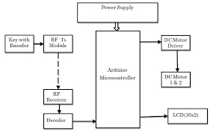
Fig 2.6:Implementation using IF and IR
Reference from ieeexplore.ieee.org
Chapter 3
- COMPARATIVE STUDY
  - Distance Short Range Communication VS Li -Fi Technology
Short-distance communication is a technology that allows vehicles to communicate with other vehicles. In this type of communication, the distance between two vehicles is short and they communicate with each other using onboard devices (OBU). The DSRC data transmission rate is 54 Mb / s, data transmission above this value is not possible, because as in the case of Li-Fi data, the data transmission rate can be up to Gbps. Instead of using on-board devices, Li-Fi has used Visible Light Communication (VLC), which is larger than DSRC Li-Fi in data transfer technology. Communication between vehicles can be from a long distance compared to DSRC. In Li -Fi, the LED sends a signal that is difficult to trace.
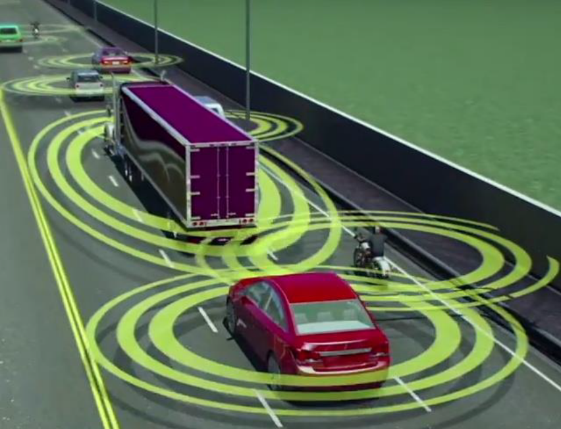
Fig 3.1: DSRC overview in communication between vehicles
Reference from hackaday.com
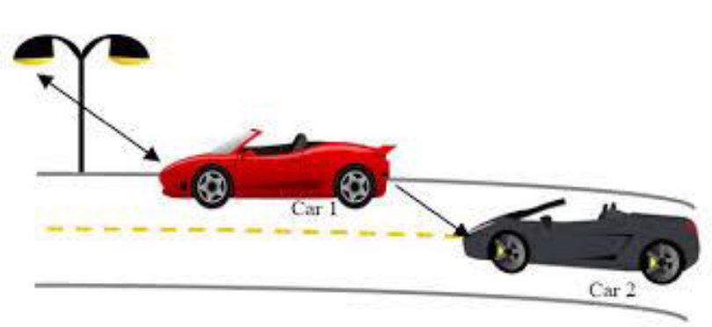
Fig 3.2: Li-Fi review in the vehicle to vehicle communication
Reference from ijsart.com

  - Wi-Fi VS Li-Fi Technology

Li-Fi technology used to describe VLC technology, used for fast wireless communication, its name is like Wi-Fi, only using light instead of the radio. Li - Fi is ideal for covering wireless data with high density in a limited space or room, and troubleshooting radio and Wi-Fi is great for the overall wireless coverage of buildings. Performance for both Wi -Fi data connections only works up to 5% performance; on the other hand, Li -Fi LEDs are characterized by high efficiency and energy consumption. Security, the problem, if you cannot see the light, you cannot access data in Li-Fi, which radio waves that can penetrate the walls, make it willing to break the security protocol. The light is easily available compared to Wi-Fi. Li-Fi is a free team that does not require a license. That's why it's cheaper than Wi-Fi.
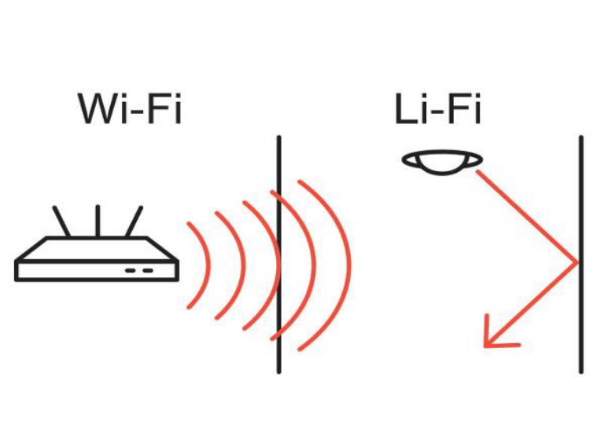
Fig 3.2: Li-Fi and Wi-Fi communication
Reference from techphlie.com

  - Bluetooth

It is the first wireless information exchange technology over short distances. This technology operates in the 2400 MHz and 24833,5 MHz band, including protective bands. This technology operates within a radius of 10 m at a transmission rate of 5 Gb / s.

  - WiMax

WiMax stands for global interoperability of microwave access. This technology enables data transfer at a rate of 1 Gb / s.

  - Gi-Fi

Gi-Fi technology is Gigabit Wireless Fidelity, which uses a very high frequency of 60 GHz for data transmission, the process of mixing and filtering the signal increases the signal strength, with minimal losses in the medium. Like Bluetooth, this technology uses short-range wireless communication. This feature competes with modern wireless communication technologies; this technology also works within 10 m range, as does Bluetooth technology.
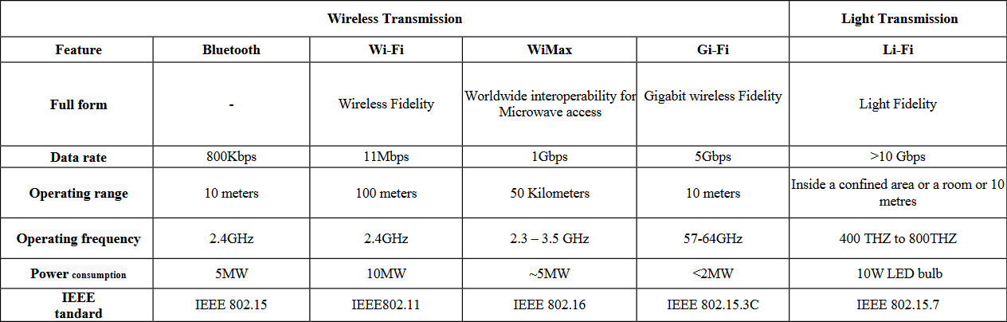
Table 3.5.1: Comparison between the technologies

Chapter 4
  - Advantages of Li-Fi
- Li-Fi can solve problems related to the insufficiency of radio frequency bandwidth because this technology uses Visible light spectrum that has still not been greatly utilized.
- High data transmission rates of up to 11Gbps can be achieved.
- Since light cannot penetrate walls, it provides security and privacy that Wi-Fi cannot.
- Li-Fi has low implementation and maintenance costs.
- Li-Fi has its advantages in electromagnetic sensitive areas such as aircraft cabins, hospitals, nuclear power plants without causing electromagnetic interference.
- Transmission of data is faster and easy.
  - Disadvantages of Li-Fi
- Internet cannot be used without a light source. This could limit the locations and situations in which Li-Fi could be used.
- Li-Fi uses visible light, and light cannot penetrate walls, the signal's range is limited by physical barriers.
- Other sources of light may interfere with the signal. One of the biggest potential drawbacks is the interception of the outdoors signals. Sunlight will interfere the signals, resulting in disturbed Internet.
- A whole new infrastructure for Li-Fi would need to be constructed.
- High installation cost of the VLC systems.

Chapter 5
  - Future Scope
- The Li-Fi technology is an advance approach on design, having the best design of internet by largely reducing the size of device which transfers data implementation by means of light bulbs.
- The LED’s can provide feasible access.
- Applications compared to any other networks in various fields which cannot be connected by on use networks.
- Li-Fi has provided a step forward development in the world of growing hunger communication.
- This technology is safe to all biodiversity including humans and progressing towards a greener, cheaper and brighter future of technologies.
  - Applications
    - Underwater Communication
Using RF signals is impractical due to strong signal absorption in water. Li-Fi provides a solution for short-range communications. Submarines could use their headlamps to communicate with each other, process data autonomously and send their findings periodically back to the surface in Underwater Remotely Operated Vehicles (ROV). Another important issue is that Li-Fi can even work underwater where Wi-Fi fails completely, thereby it’s open for military operations. Seminar Li-Fi Technology shows water vehicles which use light to communicate with each other and transfer data between them.

Fig 5.2.1: Underwater Communication
Reference from scuba.com
    - Traffic Management
Li-Fi can help in managing the traffic in a better manner and the accident numbers can be decreased. Traffic lights can communicate to the car and with each other to manage the traffic in the street.
Traffic light can play the role of the sender of the data to provide information to the car on the status of the road or about the situation of other cars. Also, cars can communicate with each other and prevent accidents by exchanging information. For example, visible lights can alert car drivers when other vehicles are too close.
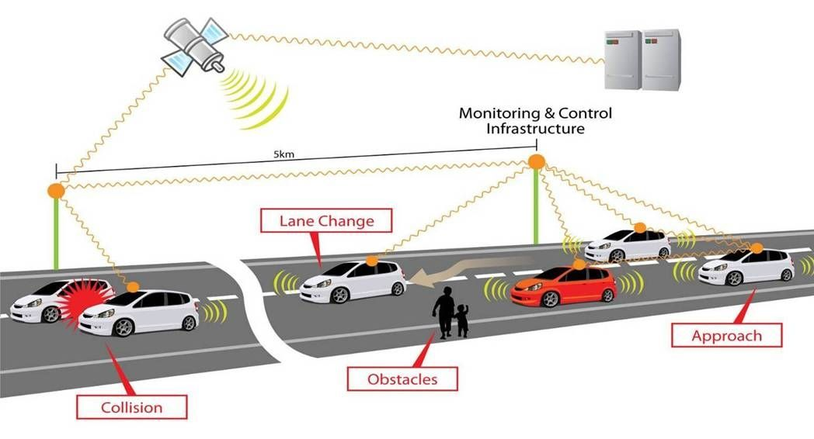
Fig 5.2.2: Vehicle to Vehicle Communication
Reference from pinterest.com
    - Medical Application
One of the most important features of Li-Fi is that it could be used in hospitals and medical settings that require the lack of RF signals which affect the medical equipment. For example, OTs (Operation theatres) do not allow using Wi-Fi due to radiation concerns because usage of Wi-Fi blocks the signals for monitoring equipment’s. So, it may be dangerous to the patient's health.

    - Sensitive Areas or Hazardous Environment
Li-Fi provides a safe communication in environments such as mines and petrochemical plants, because it doesn’t cause electromagnetic interference which appears in RF communications. Li-Fi can also be used in petroleum or chemical plants where other frequencies could be hazardous.
For ex, power plants like nuclear power plants require grid integrity and monitoring of the station temperature that need fast, inter-connected data systems. Wi-Fi and many other radiation types are bad for sensitive areas surrounding the power plants. Li-Fi could offer safe, abundant connectivity for all areas of sensitive locations. Moreover, this technology also enables us to control the growth of the plants without direct presence.
    - Smarter Power Plants
Wireless Fidelity (Wi-Fi) and many other radiation types are bad for sensitive areas. Like those surrounding power plants. But power plants need fast, inter-connected data systems to monitor things like demand, grid integrity and (in nuclear plants) core temperature.

Fig 5.2.5: Use in Power Plants
Reference from slideshare.net

Chapter 6
- Conclusion
The concept of Li-Fi is currently attracting a great deal of interest, that is because, it offers a very efficient and genuine alternative to radio-based wireless. As a growing number of people and their any devices access wireless internet, the airwaves are becoming increasingly clogged, making it more and more difficult to get a reliable, high-speed signal. This technology may solve issues such as the shortage of radio-frequency bandwidth and allow internet where traditional radio based wireless isn‘t allowed such as aircraft or hospitals. One of the shortcomings however is that it only works in direct line of sight.

